Optimization Techniques and Implementation of Green-Grey Infrastructures for Urban Stormwater Management

Name- Sangharsh Morey, roll no. 210040136

Key Message(s):

* Integrated green-grey infrastructures optimize stormwater management by balancing environmental and economic needs.
* Multi-objective optimization models improve flood control, pollutant reduction, and urban resilience.
* Larger-scale retrofitting and stakeholder-inclusive planning are recommended for future urban stormwater management strategies.

Abstract

This report reviews optimization methods for green-grey infrastructures (GGIs) in urban stormwater management, focusing on the balance between sustainable water management and climate resilience. Recent advancements, including computational resources and hydrological modeling, have increased the feasibility of implementing GGIs at larger scales. By examining quantitative and qualitative optimization goals, this report identifies the potential of GGIs to improve flood mitigation, pollution reduction, and socio-ecological resilience. Challenges remain in applying these methods at watershed scales and including socio-economic metrics. The review concludes that expanding GGI applications using surrogate-based models and prioritizing high-risk areas in phased retrofitting can maximize resilience and address budget constraints.

1 Introduction

Urban stormwater management has become increasingly challenging due to the combined effects of climate change and urbanization. These factors contribute to more frequent and intense rainfall events, overwhelming existing urban drainage systems and leading to frequent flooding, waterlogging, and pollution. Traditional drainage infrastructure, primarily composed of grey infrastructures such as pipes, drains, and detention tanks, was designed to handle historical rainfall patterns and static urban landscapes. However, as urban areas expand and impervious surfaces grow, traditional grey systems often lack the flexibility and resilience needed to adapt to evolving stormwater demands. This limitation has spurred a critical need for innovative approaches that enhance stormwater system capacity, adaptability, and sustainability.

Green-Grey Infrastructure (GGI) systems have emerged as a promising solution to address these challenges. GGIs integrate green infrastructure—such as permeable pavements, bioretention cells, green roofs, and vegetative swales—with traditional grey infrastructure. The hybrid approach aims to mitigate stormwater issues by capturing and treating runoff through natural processes (green infrastructure), while grey infrastructure ensures efficient water conveyance and storage. This dual approach not only reduces the volume and peak flow of runoff but also improves water quality, provides ecological benefits, and enhances urban resilience against extreme weather.

Recent advancements in hydrological modeling and optimization algorithms have fueled research in GGI design and implementation, with significant contributions emerging from China, the USA, and Iran. Since 2012, the availability of computational resources has enabled researchers to develop sophisticated models that simulate and optimize GGI performance, leading to a sharp increase in studies on small-scale GGI retrofits. While these studies offer valuable insights, they largely focus on specific urban sites or small catchments, leaving a gap in understanding GGIs at larger, city-wide or watershed scales.

This report provides a comprehensive review of GGI optimization techniques, identifying trends, methodologies, and current gaps. By highlighting successful practices and areas for improvement, the report aims to guide future research and support the development of sustainable, large-scale urban drainage solutions. The findings also underscore the need for socio-ecological considerations in GGI planning, stakeholder engagement, and multi-stage implementation strategies for long-term urban resilience.

**2 Methods and Data**

A systematic review of peer-reviewed articles on GGIs was conducted. Selection criteria included studies focusing on optimization of green, grey, or combined infrastructures for urban stormwater management. Key data points included optimization techniques (e.g., NSGA-II, PSO), objectives (e.g., flood volume reduction, pollutant load management), retrofitting scale, and stakeholder involvement. Figures detailing the methodology, common tools, and geographical focus of studies were synthesized to provide a comprehensive view of current practices and gaps in GGI research.

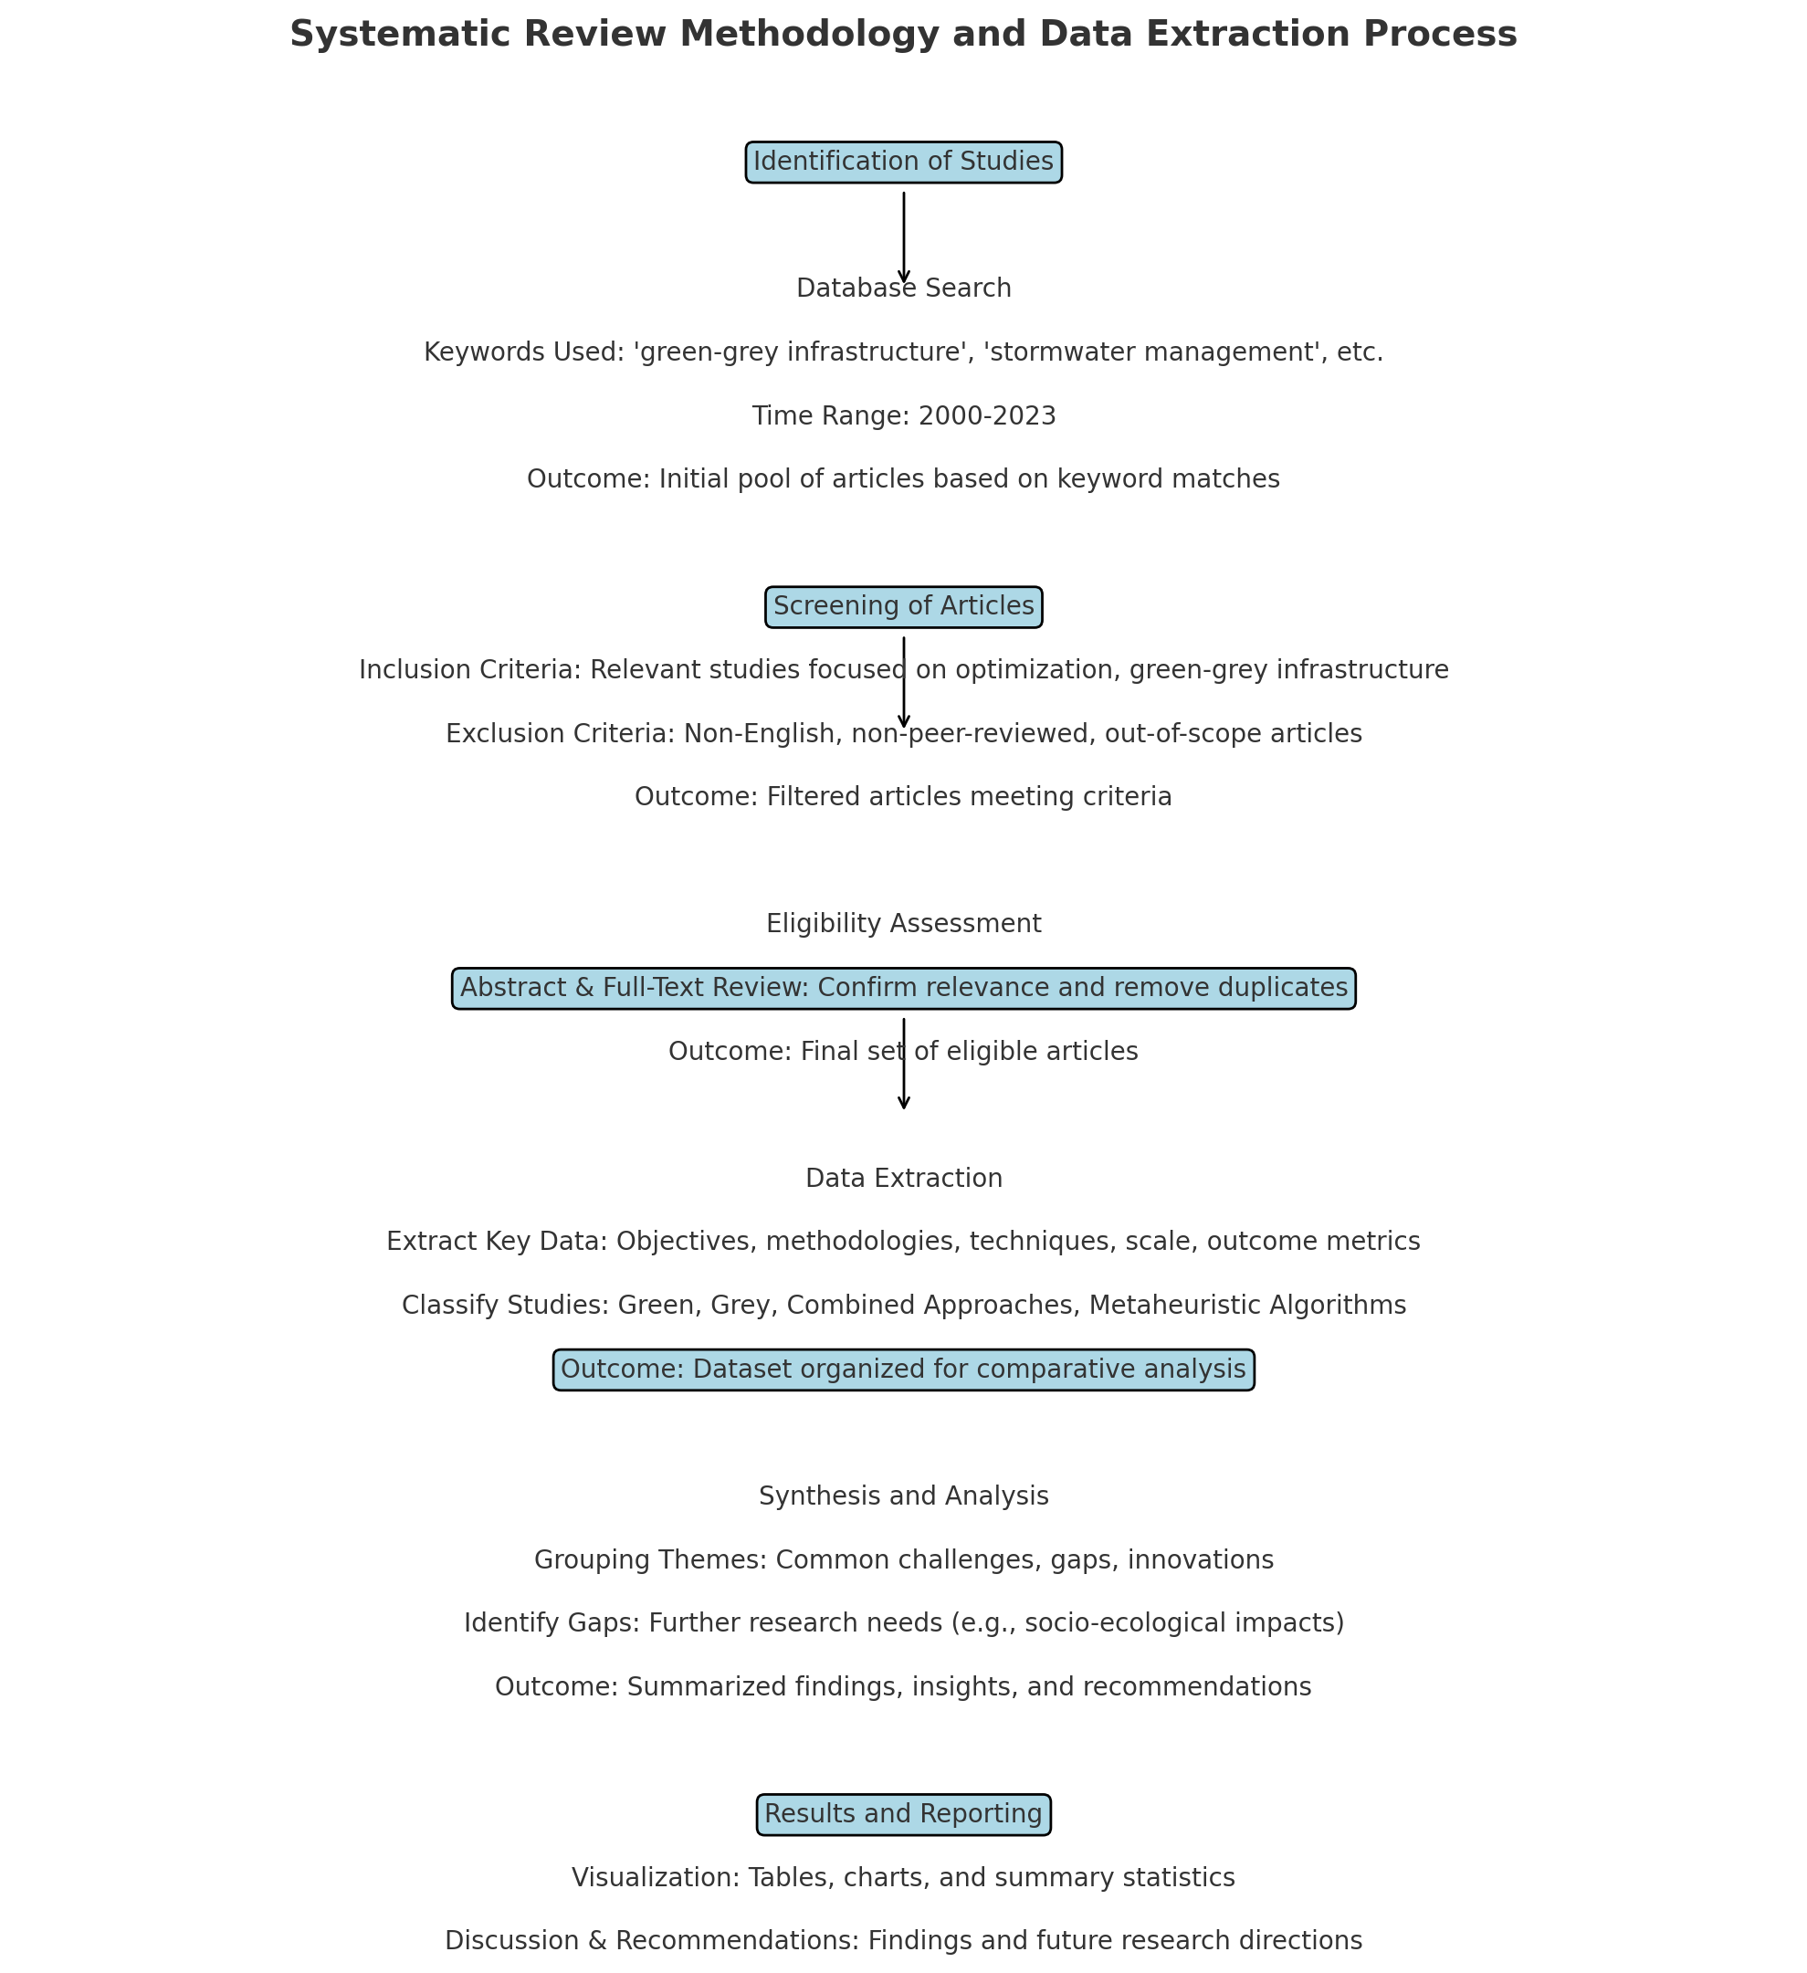

Figure 1: Flowchart of Systematic Review Methodology and Data Extraction Process

3 Results, or a descriptive heading about the results

3.1. Structural Optimization of Urban Drainage Systems: Yukun Zhang, Ersong Wang, and Yongwei Gong (2024)

In their study, Zhang, Wang, and Gong developed a structural optimization model aimed at improving urban drainage systems in response to increased flooding risks due to climate change and urbanization. Using the Sino-Singapore Tianjin Eco-City as their test site, they devised an optimization framework that integrates redundancy-based interventions. The two primary interventions explored were loop introduction and pipe diameter enlargement, each addressing different resilience needs in the system. Their approach relied on design rainfall data, derived from local meteorological records, to simulate potential flooding scenarios under extreme conditions. The optimization model utilized a multi-objective algorithm to balance cost, flood risk mitigation, and hydraulic performance.

Key findings showed that looped structures allowed for improved flow distribution, while increased pipe diameters enhanced flow capacity, making both strategies adaptable to various drainage system layouts. Zhang and colleagues concluded that a hybrid model combining these interventions produced the most resilient system, reducing peak flooding duration by nearly 30% compared to traditional methods. This study underscored the importance of adaptable infrastructure that can manage localized surges in water flow, an increasingly critical feature for urban systems globally.

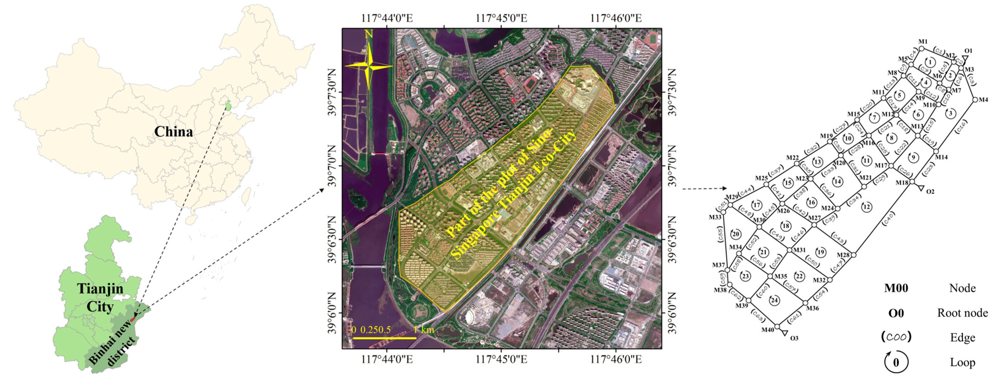

3.2. Review on Optimization of Green-Grey Infrastructures for Stormwater Management: Husnain Tansar, Fei Li, Feifei Zheng, and Huan-Feng Duan (2024)

Tansar and co-authors presented a comprehensive review of green-grey infrastructure (GGI) optimization methods in urban stormwater management, focusing on advancements in hydrological-hydraulic modeling and multi-objective optimization. Their approach emphasized the integration of sustainable practices within urban drainage systems by balancing green (natural) and grey (manmade) infrastructures. This study also identified specific countries—namely China, the USA, and Iran—as leaders in GGI research, noting a trend towards smaller-scale retrofits.

Through an extensive literature review, Tansar and his team found that most studies employed metaheuristic optimization algorithms like NSGA-II and PSO due to their ability to handle complex, multi-variable functions. They suggested that future research should adopt surrogate-based optimization to reduce computational demands, especially for large-scale projects. The review highlighted the importance of including socio-ecological objectives and engaging stakeholders in the design process to improve the public acceptance of GGIs. The authors recommended phased, multi-stage implementation approaches, especially in high-flood-risk areas, to address economic constraints effectively.

3.3. Multistage Stochastic Programming for Water Allocation Decision-Making: Juan Marquez, Leonardo H. Talero-Sarmiento, and Henry Lamos (2022)

Marquez and colleagues introduced a multistage stochastic programming approach to water allocation, which has implications for stormwater management by addressing uncertainty in resource allocation. Their framework focused on agricultural water use but has broader applications, particularly in urban stormwater scenarios where climate change and unpredictable rainfall patterns affect resource management. This model uses sequential decision-making across various scenarios, each stage adjusting based on updated data and conditions, such as seasonal water availability or changing demands.

Their analysis demonstrated the effectiveness of this approach in managing resource uncertainty, achieving an optimal balance between water allocation and resilience planning. A key aspect of their model is its flexibility, enabling rapid adjustments to allocations as new data emerges. This study contributes to stormwater management by highlighting stochastic programming's role in planning under uncertainty, a crucial factor given the increasing unpredictability of urban hydrological cycles. The authors emphasize that this approach could support sustainable stormwater management, particularly in regions facing extreme weather variability.

3.4. Review of Multi-Stochastic Approaches in Water Allocation under Uncertainty

This paper reviewed various stochastic methodologies used in managing water allocation under uncertain conditions, providing a foundation for applications in urban stormwater optimization. The authors examined models that address multi-dimensional uncertainty factors—such as seasonal variations, unexpected demands, and climate shifts—through multistage and two-stage programming techniques. By synthesizing these approaches, the review identified critical strengths and weaknesses, with two-stage methods excelling in immediate, short-term planning and multistage models offering adaptability for long-term changes.

A significant insight was the emphasis on integrating stochastic methods within urban stormwater management to mitigate flood risks and optimize resource distribution. The authors recommended expanding these models to accommodate larger urban catchments, using hybrid stochastic-deterministic approaches for enhanced resilience. They concluded that multi-stochastic approaches offer significant advantages for flexible, adaptive urban stormwater systems, especially in regions vulnerable to extreme weather events.

3.5. Optimization Techniques in Urban Stormwater Management: Techniques and Applications

This paper explored the application of various optimization techniques to urban stormwater management, including genetic algorithms, particle swarm optimization, and simulated annealing. The authors focused on how these techniques could be adapted for large-scale, multi-objective projects that require balancing flood control, water quality, and economic considerations. Their approach assessed each technique's performance in handling non-linear, multi-variable problems typical in stormwater infrastructure planning.

The analysis revealed that NSGA-II and PSO are particularly effective due to their robust multi-objective handling capabilities, with applications extending to both green and grey infrastructure designs. This study highlighted the growing potential of machine learning and AI to improve optimization efficiency, especially when integrated with existing hydrological models. The authors proposed that future research should explore hybrid optimization techniques combining machine learning with traditional models to achieve higher accuracy and efficiency in stormwater management.

4 Conclusions

This review explores the progress made in the field of Green-Grey Infrastructures (GGIs) for urban stormwater management, a critical area of research that seeks to address the complex challenges posed by urbanization and climate change. As the principal investigator of this study, my research has critically examined the optimization methods employed to enhance the functionality and efficiency of GGIs, which integrate green and grey infrastructure components to create more resilient urban drainage systems (UDS).

Significant advancements in computational resources over the last decade have revolutionized our ability to model and optimize the design of GGIs. The adoption of multi-objective optimization frameworks, supported by hydrological-hydraulic models, has been pivotal in evaluating and enhancing the performance of GGIs under various environmental conditions. These frameworks facilitate the simultaneous optimization of multiple objectives, such as minimizing runoff and pollution while maximizing economic efficiency and ecological benefits.

Despite these advancements, my findings indicate that the bulk of GGI research has been predominantly focused on small-scale, site-specific implementations. Such studies are instrumental in understanding localized impacts and benefits but fall short of capturing the complexities and interactions that manifest at larger scales, such as entire watersheds or urban regions. The limited scope of these studies is primarily due to the high computational costs associated with scaling up models to simulate larger systems comprehensively.

To address this gap, my review suggests a shift towards implementing watershed-scale studies that can offer a more holistic understanding of GGIs' impacts on stormwater management. By leveraging surrogate-based optimization methods, researchers can significantly reduce the computational burden associated with traditional simulation models. Surrogate models approximate the more complex hydrological models through simpler mathematical forms, which are faster to compute and can efficiently explore large solution spaces. This approach not only enhances computational efficiency but also maintains acceptable accuracy in predicting system behaviors under various scenarios.

Moreover, the review underlines the importance of developing stakeholder-inclusive frameworks for GGI planning and implementation. Engaging local communities, policymakers, and industry stakeholders from the outset is crucial for the successful adoption and sustainability of GGIs. These frameworks should incorporate socio-ecological metrics that go beyond traditional engineering objectives to include factors such as social acceptability, ecological impact, and long-term resilience. By doing so, GGIs can be designed to align more closely with the broader sustainability goals of urban environments.

Throughout my investigation, I have advocated for an integrative approach that considers not only the technical aspects of GGIs but also the socio-economic and ecological dimensions. This comprehensive perspective ensures that the development and optimization of GGIs are grounded in a real-world context, making them more likely to be adopted and supported by the communities they are designed to serve.

In conclusion, this review has mapped out a future research trajectory that emphasizes scalability, computational efficiency, and multi-disciplinary integration. As we move forward, it is imperative that the field of urban stormwater management embraces these broader and more inclusive approaches to truly capitalize on the potential of GGIs. This will not only enhance the resilience of urban infrastructure but also contribute to the sustainability and livability of urban environments worldwide. Through this project, I have laid the groundwork for future studies to build upon, aiming to catalyze a shift towards more sustainable and effective stormwater management solutions.

Top of Form

Bottom of Form5 References

1. Tansar, H., Li, F., Zheng, F., Duan, H. (2024). A critical review on optimization and implementation of green-grey infrastructures for sustainable urban stormwater management. *AQUA - Water Infrastructure, Ecosystems and Society*, 73(6), 1135–1150.

2. Zhang, Y., Wang, E., Gong, Y. (2024). Structural optimization of urban drainage systems for mitigating urban floods. *Water*, 16(12), 1696.

3. Juan Marquez, L.H., Talero-Sarmiento, H.L., Lamos, H. (2022). Multistage stochastic programming for water allocation in agriculture: A literature review. *Agricultural Water Management*, 223, 105-113.

4. Grech, V., 2017. WASP–Write a Scientific Paper course: why and how. *Journal of Visual Communication in Medicine*, 40(3), 130-134.

5. Lipshitz, R., Strauss, O. (1997). Coping with uncertainty: A naturalistic decision-making analysis. *Organizational Behavior and Human Decision Processes*, 69(2), 149-163.